Keyword Planning Logic

The Keyword Planning Logic: A Core Marketing Dashboard Utility
To reflect the true scope of search intent across all customer touchpoints, the Keyword Planner is being permanently repositioned from a subsection of the SEO Manager into a standalone, core utility feature within the overarching Marketing Dashboard. Keywords are no longer just an SEO metric; they are the fundamental search terms that act as gateways to our ICPs. By elevating this function to a dashboard-wide utility, we ensure that every department—from social media teams structuring LinkedIn bios to SEO or GMB—operates from a single, unified keyword universe, breaking down data and establishing search intelligence as the baseline for all marketing operations.

System Role Clarification:
This module acts as a mandatory first step post-onboarding.
- SEO Manager and GMB Manager remain locked until keyword planning is completed
- Keyword outputs are tagged and routed automatically to respective modules

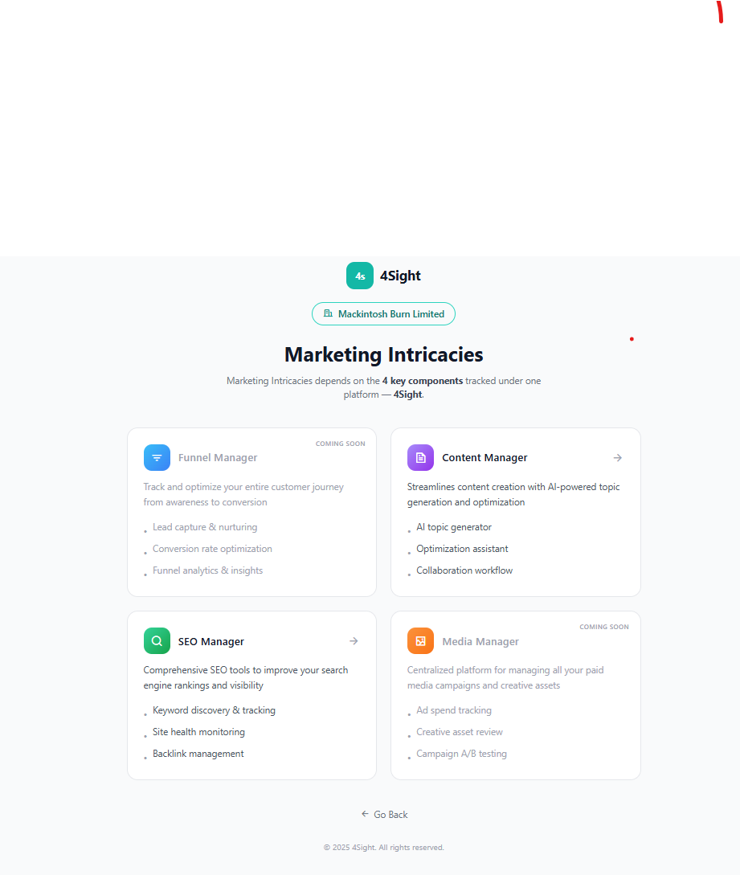

The standalone utility feature will be added in this screen (Marketing Dashboard)

Onboarding → Keyword Planning Data Flow
The Keyword Planner is directly dependent on structured inputs collected during onboarding. These inputs are normalized and used as primary signals for seed generation, keyword expansion, and routing.
Onboarding Inputs Used: (Please refer to the On boarding document and Prototype to understand the fields and their nature)
- Business Name
- Website URL
- Business Description
- Products & Services
- Location Scope
- Competitor Inputs (Name + URL)
- Physical Presence Indicator (Online / Offline / Hybrid) - Please refer on boarding document
- Business Type
- Business Reach Type

Input Processing Logic (Conversion of on boarding inputs to Keyword Universe)

=> Step#1 : Seed Keywords ( from Website URL)
=> Step#2 : Additional Business Type Validation & Few Ready Keywords (Business Description + Product & Service ). Example of a ready keyword Premium Hair Spa for Men . Business Type Validation is needed to ascertain (Online/Offline/Hybrid tags) brand type and that is also taken as a specific input from the brands while on boarding
=> Step#3 : For adding location in keywords for example Premium Hair Spa for Men in Behala
=> Step#4 : Competition layer is only for validating our keyword universe and also identifying Clusters or keywords (both primary and secondary)
=> Step#5 : Physical Presence Indicator that defines the Business Type Validation and is substantiated Step#2
1. Website URL:
- Crawl key pages (Home, Product, Service, Blog)
- Extract:
  - Page titles
  - H1/H2 tags
  - Repeated terms
- Convert into seed keywords as many as you can extract ( This has already been answered in Tab2)
2. Business Description:
- NLP extraction from website pages ( Product, Services) to identify:
Extraction Layer | Purpose | Example
Core Offerings | Identify exact sellable products/services | Menswear Brand → Cotton Shirt, Linen Shirt, Wedding Sherwani | Unisex Salon → Hair Spa for Men, Keratin Treatment, Bridal Makeup
Category Terms | Identify broader business category themes | Menswear Brand → Menswear, Ethnic Wear, Formal Wear | Salon → Unisex Salon, Beauty Salon, Hair Salon
Modifiers | Identify search-intent qualifiers attached to offerings | premium, affordable, luxury, designer, custom, organic, handmade, budget-friendly

Example Logic:
Business Description:
“We are a premium menswear brand offering custom wedding sherwanis and linen shirts across Kolkata.”
System Extraction:
- Category Terms → Menswear Brand
- Core Offerings → Wedding Sherwani, Linen Shirts
- Modifiers → Premium, Custom
3. Location Scope: (From Onboarding Screen)
- Used to:
  - Generate geo-modified keywords
  - Enable GMB routing
Example:
- “Kolkata” →
  - menswear store in Kolkata
  - best kurta shop Kolkata

4. Competitor Inputs:
- Extract:
  - Ranking keywords
  - Page-level keyword themes
- Used only for:
  - Validation
  - Gap expansion
Example:
If Competitor is “Manyavar”
They rank for:
- wedding kurta for men
- sherwani for groom
- ethnic wear for men
What type of pages do they have:
Competitor website has:
- /wedding-collection/
- /kurta-for-men/
- /festive-wear/
This tells us:
- What topics/categories matter in the market
- These become clusters or themes, not just keywords

Output of Input Processing Logic , as explained above
A refined Seed Keyword Set (10–15 terms) enriched with:
- Business relevance
- Location modifiers
- Competitor context

Decision Priority Order (This is just to reiterate selected as we have already discussed above)

This section is to just understand the logic discussed above and also has an additional point of Keyword Intent ( Sohini, to add that in the document)
The system processes inputs in the following order:

Step 1 → Physical Presence Indicator (PRIMARY INPUTfor business type validation received from Onboarding)
This decides the routing logic:
- Online → SEO-first keyword universe
- Offline → GMB-first keyword universe
- Hybrid → Split keyword universe

****CASE 1: ONLINE BUSINESS

Example:
E-commerce menswear brand (no stores - only online sales)

Keyword Logic
- Focus:( Intent)
  - Informational
  - Transactional (non-location)
Examples:
- buy mens shirts online
- best menswear brands in India

Competitor Logic
- Only include:
  - E-commerce competitors
- Exclude:
  - Local stores
  - “near me” competitors

GMB Behavior
- Disabled / Not prioritized

Output to User
Show:
- “SEO Keyword Universe” only
- No local keyword section

****CASE 2: OFFLINE BUSINESS

Example:
Salon or clinic with only local presence

Keyword Logic
- Focus:
  - Local intent
  - “near me”
  - city-based
Examples:
- salon in behala
- best dermatologist near me

Competitor Logic
- Only include:
  - Local competitors
- Exclude:
  - National brands

SEO Behavior
- Disabled / Not prioritized

Output to User
Show:
- “Local Keyword Universe (GMB)”
- Highlight map visibility

****CASE 3: HYBRID BUSINESS (MOST IMPORTANT)

Example:
Menswear brand (stores + PAN India sale through website)

Keyword Logic
Split into TWO streams:

1. Local Keywords (GMB)
- menswear store in Kolkata
- kurta shop near me

2. Non-Local Keywords (SEO)
- buy mens kurta online
- best menswear brands India

Competitor Logic
Split competitors into TWO buckets:
Type | Example
Local competitors | Kolkata stores
Online competitors | Andamen, Manyavar

Output to User
Show 2 sections:

Section 1: Local Keyword Opportunities (GMB)
- X keywords
- Y competitors

Section 2: Organic Keyword Opportunities (SEO)
- X keywords
- Y competitors

Step 2 → Business Type to be extracted from On Boarding (CONTEXT LAYER)
Validation or Updation Step:
- Keyword Universe
- Intent patterns
- Competitor type
Sohini, to add the relevant examples

Step 3 → Business Reach to be extracted from On Boarding (SCALING LAYER)
Defines:
- Geo modifiers (e.g., “near me”, “in Kolkata”, “India”)
- Keyword expansion boundaries
Sohini, to add the relevant examples

Step 4 → Website (DATA ENRICHMENT LAYER)

How to determine if the website info can be taken into consideration
Used only for:
- Seed extraction
- Existing keyword validation (if data exists)

How the System Determines Whether Website Data Can Be Considered
The platform first validates whether the website contains sufficient structured and crawlable business information.
Website data can be considered ONLY IF:
- Website is live and accessible
- Core pages exist (Home/About/Services/Products)
- Page content is indexable and not image-only
- H1/H2 tags or readable content exists
- Website is not under construction/placeholder-only
- Content relevance matches onboarding business inputs

Website Data Should Be Ignored or Downweighted IF:
- Website is empty or template-based dummy content
- Only one landing page exists with minimal text
- Website content contradicts onboarding inputs
- Website has no meaningful headings/content structure
- Website is built entirely as images/PDFs without crawlable text

Example 1 — Website Data Considered Valid
Business:
Menswear Brand
Website Pages:
- /wedding-sherwani
- /linen-shirts
- /mens-blazers
Detected H1s:
- Premium Wedding Sherwanis
- Linen Shirts for Men
- Designer Blazers
System Action:
Use extracted phrases as seed keywords.
Generated Seed Examples:
- wedding sherwani
- linen shirts for men
- designer blazers

Example 2 — Website Data Ignored
Business:
Salon
Website:
Single-page website saying:
“Welcome to our salon. Contact us today.”
No service pages.
No structured headings.
System Action:
Ignore website scraping weight.
Increase dependency on:
- onboarding inputs
- competitor signals
- category-level keyword expansion

Step 5 → GA & GSC (PERFORMANCE LAYER)
Used only if data exists:
- Ranking validation
- Opportunity prioritization

Example 1 — Ranking Validation
Keyword: “mens linen shirts”
GSC Data Shows:
- Current Position → 12
- Impressions → High
- CTR → Low
System Interpretation:
The keyword already has visibility and is close to Page 1.
Action:
Tag as: “On-the-Fence Opportunity”
Priority Score Increased.

Example 2 — Opportunity Prioritization
Keyword: “premium sherwani for groom”
Keyword Planner:
- Medium volume
- Medium difficulty
GA/GSC Data: Landing page already receives traffic from related queries.
System Interpretation: Existing topical authority already exists.
Action: Prioritize instead of starting a completely new cluster.

Example 3 — Existing Traffic Validation
Keyword Planner Suggestion: “custom tuxedo for men”
But GSC shows:
- Zero impressions
- No related ranking footprint
System Interpretation: Low existing relevance.
Action: Keep in exploration bucket instead of immediate priority bucket.

Example 4 — Existing High-Performing Asset Protection
GSC Shows: Page ranks Position 3 for: “best salon in Behala”
System Action: Mark keyword cluster as:Maintenance Mode
Recommendation: Avoid major content/URL restructuring on this page.

1. Keyword Processing Workflow (Operational Sequence)
Skip any step, and the keyword universe becomes fundamentally flawed. This 6-step sequence is mandatory for all brands using the dashboard.

Step 1: Seed Consolidation
Combine and normalize all validated seed terms collected from:
- onboarding inputs
- website extraction (if valid)
- competitor themes
- category-level keyword patterns
Output:
10–15 refined foundational seed terms for expansion.
Step 2: Universe Expansion:
- Input seeds into the keyword engine(Google Keyword Planner) to generate a baseline universe (e.g., 10 seeds yielding 100+ expanded keywords).
Step 3: Multi-Dimensional Segmentation:
- Do not evaluate keywords in a vacuum. Bucket the expanded list immediately using the core metric mix (Volume, Difficulty, Growth, Intent, Business Potential).
Step 4: Intent & Clustering:
- Group segmented keywords via Parent Topic. Do not create 100 pages for 100 keywords; group them into distinct clusters to avoid cannibalization.
Step 5: Competitive SERP Overlap:
- For every keyword, map the top 5 to 10 ranking domains. Identify unique competitors, track their frequency of appearance across the 100 keywords, and extract their ranking keywords that are missing from your universe (expanding the 100 to 120+).

2. Current Asset Audit (Conditional Logic)

This step splits based entirely on whether the brand has historical search data in the dashboard.
- Path A: Existing Brands
  - Action: Cross-reference the final universe against the brand's current organic standings to categorize by Rank Status.
  - Outcome: Segregate keywords into "Page 1 Maintenance" and "On-the-Fence Prioritization" (Positions 11-20).
- Path B: New Brands (Zero Organic Presence)
  - Action: Target URL Mapping & Architecture Readiness.
  - Logic: Since there is no rank status to audit, you must map every Parent Topic cluster to a proposed, logical URL structure on the site.
  - Outcome: Validate that the website's architecture can actually support the keyword clusters (e.g., ensuring there is a dedicated /blog/ for informational clusters and a /services/ for transactional clusters) before finalizing the keyword list.

3. The Segmentation Metrics (The Proper Mix)
Relying on standard search volume is a critical failure. Use this exact mix to separate high-value terms from waste.
- Traffic Potential (TP) over Search Volume (SV): SV is the average searches for one exact phrase; TP is the total traffic the #1 ranking page actually receives from all its ranking variations. Never prioritize based on SV. Prioritize strictly on TP.
- Keyword Difficulty (KD): Represents the estimated number of referring domains needed to hit the Top 10. High KD is not a deterrent; it is an indicator of a "link-worthy" topic. Do not blindly filter for 0-10 KD.
- Growth Trend: Analyze the 6 to 12-month trajectory. Eliminate keywords where an annual average masks a steep decline or a one-off seasonal spike. Prioritize consistent upward trajectories.
- Business Potential (0-3 Scale):
  - 3: The product is an irreplaceable solution to the search query.
  - 2: The product helps significantly but isn't strictly essential.
  - 1: The product can only be mentioned fleetingly.
  - 0: Zero alignment.
  - Rule: Automatically deprioritize 0 and 1. Focus exclusively on 2 and 3.
- Intent Classification: Strictly categorized as Informational (blog/education), Navigational (brand/location/Google My Business), or Transactional (product/service purchase).

Intent Mapping Logic
Intent is mapped using a combination of:
  - keyword wording patterns,
  - modifier detection,
  - SERP behavior,
  - and landing page type analysis.

Intent Type | Detection Logic | Example Keywords
Informational | “how”, “best way”, “guide”, “tips”, “what is” | how to style linen shirts
Navigational | brand/location-focused searches | Manyavar Kolkata, salon near me
Transactional | purchase/service/action intent | buy sherwani online, book hair spa

Example 1:
Keyword:
“best dermatologist near me”
System Detection:
- “best” modifier
- “near me” geo intent
- SERP contains Maps listings
Mapped Intent:
Navigational / Local Intent
Routed To:
GMB-first keyword universe

Example 2
Keyword:
“buy linen shirts online”
System Detection:
- “buy” modifier
- “online” transactional signal
- SERP contains e-commerce/category pages
- No geo/local intent detected
Mapped Intent:
Transactional / Organic Search Intent
Routed To:
SEO-first keyword universe

4. Brand-Maturity Keyword Matrix (Identifying Exact-Value Keywords)
The exact same keyword universe must be filtered differently based on the brand's current domain authority and market position.
- New Brands (Zero to Low Authority)\Filter Logic: High Growth + Low/Medium KD + High Business Potential (2/3) + Long-tail variants.
  - Action: Ignore high SV keywords completely. Target niche informational clusters and specific transactional long-tail queries. Focus heavily on "On-the-fence" competitor keywords (where competitors are weak).
- Mid-Size Brands (Moderate Authority, Established Traffic)
  - Filter Logic: High Traffic Potential + Content Gaps + Parent Topic Clustering.
  - Action: Run Content Gap analyses against the 50 unique competitors identified in Step 5. Target keywords where competitors rank, but the brand does not. Consolidate into authoritative cluster pages.
- Large/Enterprise Brands (High Authority, Ranking Everywhere)
  - Filter Logic: High KD + Commercial/Transactional Intent + SERP Dominance.
  - Action: Target high-KD keywords specifically for link equity and brand dominance. Focus heavily on defending existing Page 1 assets and aggressively capturing high-BP transactional terms.

4. Data Dependency Handling

Case 1: No GA/GSC Connected

Use:

Keyword Planner data only

Competitor benchmarks

Case 2: GA/GSC Connected but No Data

→ Treat as new brand
→ Ignore performance layer

Case 3: Website Not Optimized

Ignore website scraping weight
Increase dependency on:

Business inputs

Competitor signals

The "Rank Status" Provision
Once keywords are segmented and prioritized by brand maturity, they must be tagged based on the brand's current SERP position to dictate immediate workflow.
- Already on Page 1 (Positions 1-10):
  - Status: Maintenance Mode.
  - Action: Do not alter the page content or architecture. Leave it alone unless it drops in ranking. The only permissible action is minor, passive backlink fortification.
- On the Fence (Positions 11-20):
  - Status: Immediate Prioritization.
  - Action: These represent the highest ROI opportunities. A minor content tweak or a small, targeted backlink push will likely bump these to Page 1, resulting in immediate, massive traffic gains.

5. Cross-Channel Utility (Beyond SEO)
Because this planner is a Marketing Dashboard utility and not only for SEO, other departments must pull from this exact same structured universe.
- Social Media: Pulls Transactional and Navigational keydoms to structure LinkedIn/Facebook bios, company descriptions, and profile SEO.
- Content/Editorial: Pulls Informational Parent Topic clusters to build the editorial calendar and ensure no cannibalization across blog posts.
- Paid Media: Pulls High CPC and Business Potential 3 keywords to ensure ad spend aligns with exact-value search terms where the brand is an irreplaceable solution.
- Product/Support: Pulls trending questions (sourced via Quora/Reddit integration in Step 2) to identify feature requests and FAQ content needs.

Tech Team Queries
  - We need good examples of foundational terms and seed terms
Seed terms are broad, core representations of what the business does or sells.
Menswear Example:
- menswear
- formal shirts
- wedding suits
- blazers for men
- ethnic wear men
- men’s clothing store

Salon Business:
- hair salon
- beauty salon
- haircut for men
- haircut for women
- hair spa
- bridal makeup
- facial services
- hair coloring

Real Estate Developer:
- residential apartments
- flats for sale
- new housing projects
- luxury apartments
- 2 BHK flats
- real estate developer
- property in [city]
- gated community homes
Rule:
- 1–3 words
- No long-tail phrases
- Directly tied to product/service
- Free from modifiers like “best”, “cheap”, “near me”

  - if no website and the customer is not pro in using keywords,
System generates seeds using:
- Business description
- Product/service inputs
- Business type
Logic:
- Extract nouns + service phrases using NLP
- Rank by frequency + relevance
- Auto-select top 10–15
No dependency on customer expertise rather the platform is guiding him/her with the best possible keyword universe.

  - if the customer gives more than 15 how to choose the best?

Customer will never provide seed directly. Seeds need to be derived as mentioned earlier and explained in the document. Higher number of seeds will result in larger number of keyword universe which in turn will make the process more business relevant.

For now we can keep the list (keyword universe) and certain filters (sort by relevance, volume, difficulty etc) from which the customer can select the final set of keywords, going forward (ver 1.0+) we can suggest the 4sight recommends keywords using a proprietary logic that uses best practices like keyword mix, prioritzation of keywords based on KD, Volume, relevance etc.

  - Should Competition's webpage constitute input ?
YES, but controlled use
Used for:
- Validation
- Gap identification

The API takes, quite a further inputs as example the URL, Location, Language etc, are they required.

Input | Required | Why
Seeds | Mandatory | Core input
Location | Mandatory | Geo relevance
Language | Mandatory | Keyword accuracy
Website URL | Optional | Only for refinement (breaks for weak/new sites )

This is the typical output we will receive
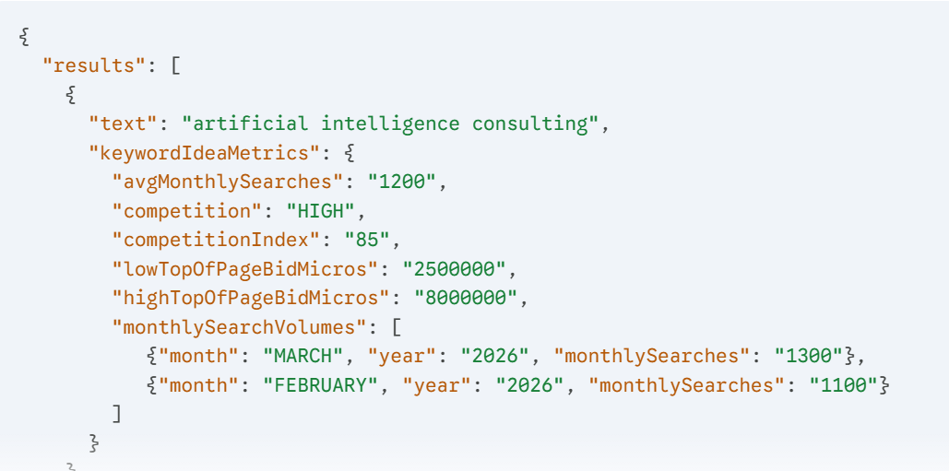
How to quantify Difficulty, Growth, Intent, Business Potential from the above values.

Growth = (latest month - previous month)/previous - evaluate over 6month
Keyword difficulty - direct parameter
Intent - always a learning parameter. We have explained the different types of intents.
How, what, guide related keywords = informational
Buy, best, top, specific occasion related keywords = transactional
Business relevance - mentioned the steps in the document itself where keywords will be generated in accordance to the business

Not sure about the 100 page thing, though, I got the idea of clustering and it makes sense, but that brings to another question:
can pages within a site have different keywords attached ?
Yes.
- One primary keyword per page
- Multiple secondary keywords allowed

If so, how to deal with that.
Cluster keywords by same search intent
Assign:
- 1 primary keyword
- 5–10 secondary keywords
Example:

Menswear (Hybrid Business)

Cluster: Wedding Wear for Men (Transactional Intent)
Primary Keyword:
- wedding suits for men
Secondary Keywords:
- groom outfit for men
- sherwani for men wedding
- men’s wedding attire India
- designer wedding suits men
- best wedding dress for men
- wedding blazer for men
- ethnic wedding wear men
This works because:
- All keywords solve the same user intent → buying wedding wear
- One page can rank for all
Also , is there an upper or lower limit to the number of clusters?
Cluster count is dynamically derived based on keyword volume, but guided by the following ranges:

Scenario | Cluster Count
Low keyword universe (~50 keywords) | 5–10 clusters
Medium universe (~100 keywords) | 10–15 clusters
High universe (~150+ keywords) | 15–25 clusters

How many keywords are expected after clustering ? Please provide a guideline to choose the keywords from the clusters.

It is a concept of 1 to many mapping. So if we are choosing 20 final keywords, the expectation is that if the brand gets rank on those 20 keywords, then actually he is getting search visibility for a larger number of keywords, because 1 cluster keyword = many secondary keywords. Just to clarify that this is a customer delight perspective and not a necessity that you always have to choose a cluster keyword.

We are going to search by each keyword and scrap the top 10 results
Then we rank the top 10 appearing domains ( By taking the frequently occurring ones )
eliminate the aggregators who are the competitors
We find the ranking keywords of the competitors
Enhance our keyword universe by that ( How many ?)

Understanding is correct. The quantification of the process is something that we cant comment on. The only feedback would be that the customer should see the result in a desirable time window.

